Hookshot Heroes Design Document

**Team Members:**

Bryce Cameron #07262361

Helen McCartney #20023665

Jerry Hsiung #18044188

Josh Anderson #21018241

# Ideas/Inspiration

When discussing 2D video games, their design, devolvement and studio’s ability to overcome limitations, it was hard not to include Nintendo’s contribution with the likes of Zelda and Mario.

When discussing with our team, we all showed interest in puzzle games. With the skills and knowledge that we have gained through this course and our assignment 1, we thought that we had a good foundation for building a dungeon crawling Zelda like game.

The room-based puzzles of Zelda’s dungeons were the source of inspiration for us to build a game that has players complete grid-based maze puzzles to proceed to the next level.

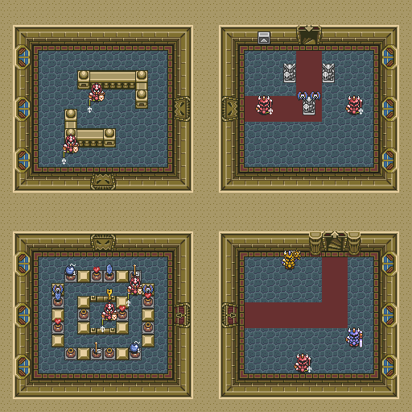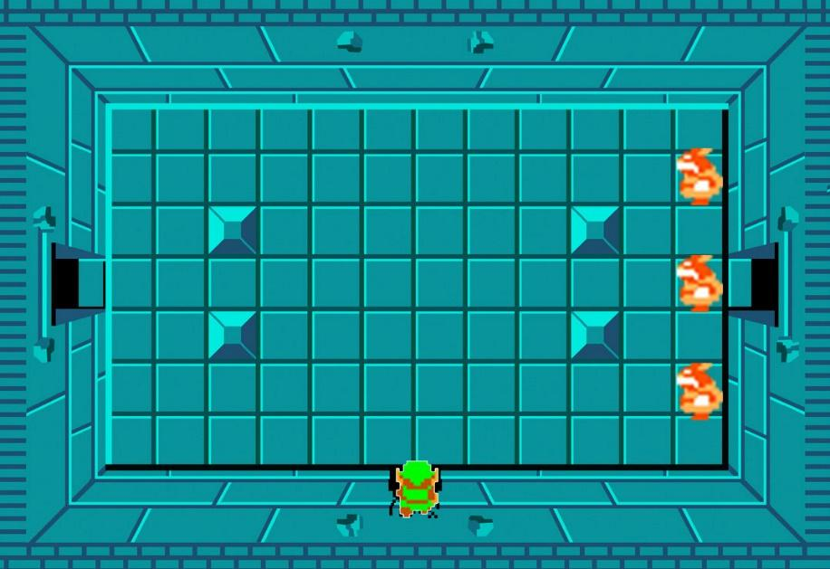

To enhance the game and the player’s experience, we wanted to add an ability that improved the player's simple grid-based movement. To achieve this, we decided to give the player a grappling hook ability. This not only made the player’s movements more enjoyable, but it also allowed us to develop the level / maze design around this ability.

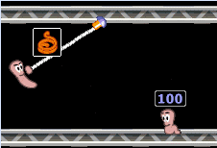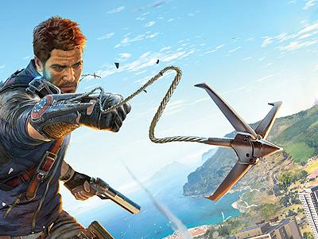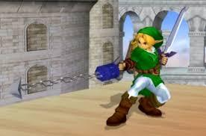

# Design Decisions

With the key ideas of rooms, where the player needs to navigate a maze, using standard movement and a grappling ability, we were able to start working on the game design.   
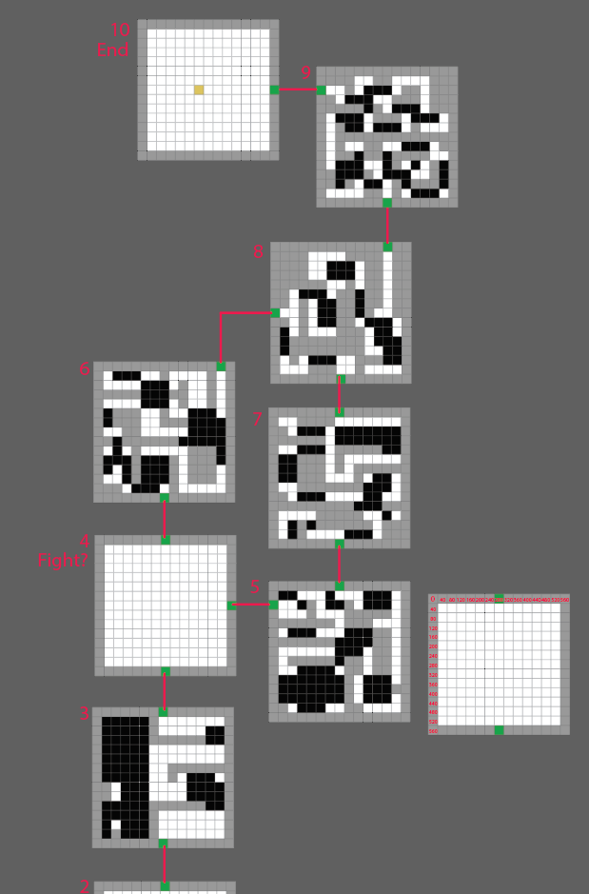

This started with researching different maze ideas and applying this knowledge to our game’s mechanic. From here we were able to start to design each room’s layout and make sure the maze and game play fitted together.

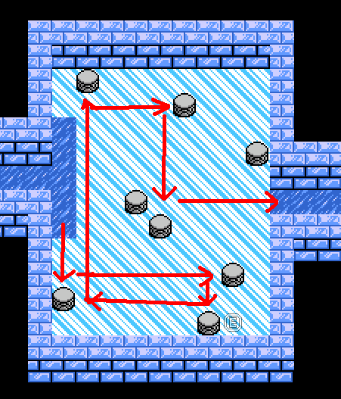

To combine the maze style and grappling ability together, we used a ground hazard (lava) in which the player would need to traverse with their grabbling ability in order to continue. Rules were placed on the grappling ability in order to define what was achievable for the player while using the ability. This then helped us fine tune the room design.

Once the maps and room designs were finalized we continued to add additional gameplay items such as collectable items for points (gold), health (food), damage (bombs).  
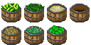

We then added enemies to fight such as the Flying Terror and the Skeletal Warrior.   
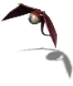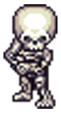

# Features

* Use Grapple to hook onto walls, jump across obstacles and attack enemies.
* 10 unique dungeon levels to solve.
* Non-linear game progression ie from level 4 there are branching paths the player can choose between that meet up later.
* Treasures to collect to increase score.
* Collect plants to add health.
* Defeat enemies - flying terrors and skeletal warriors.
* 2 unique boss fights.
* 3 Modes - Single Player, Two Player, Quest Mode (Escort an NPC).
* PC and NPC speech bubbles - Read your character’s thoughts as they collect items and battle enemies. Comments generated with ChatGPT.
* Suspensive music and immersive sound effects.
* Character / boss and item animations.
* Two end-game bonus levels after defeating all the bosses.

Detailed discussions on the game architecture, game UML diagrams, AI state machines designs, ChatGPT, and NPC characters generation, can be found in README.md.

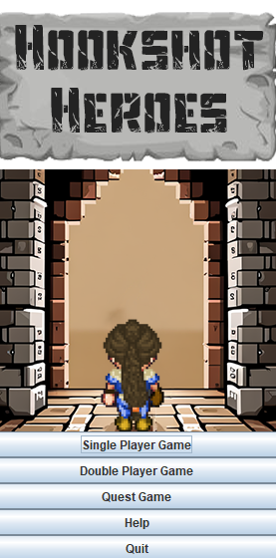

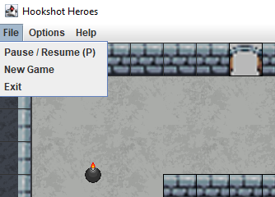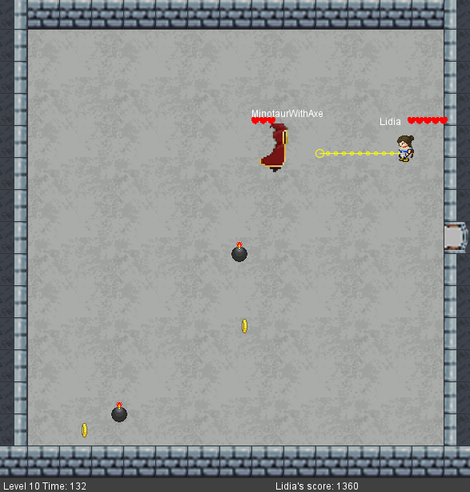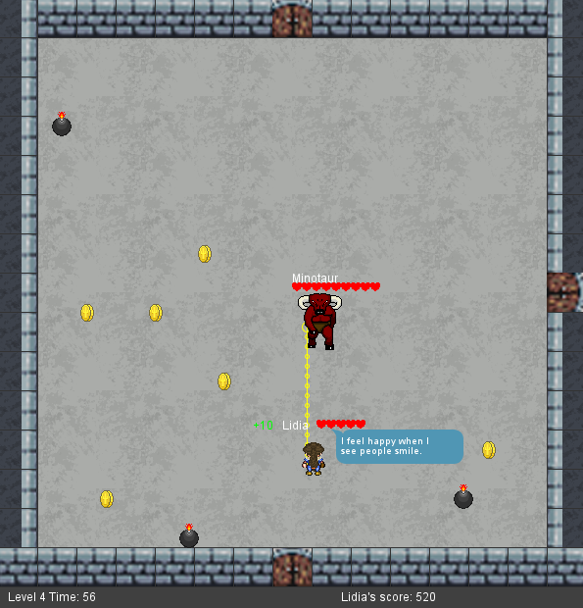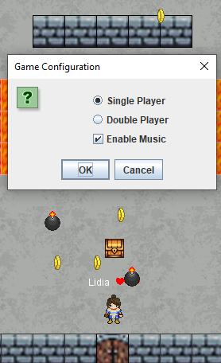

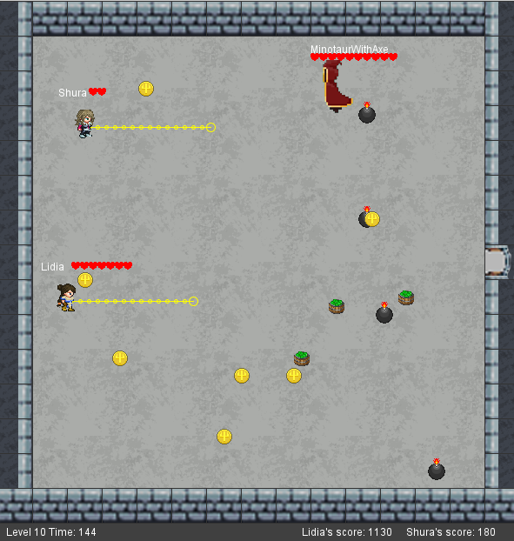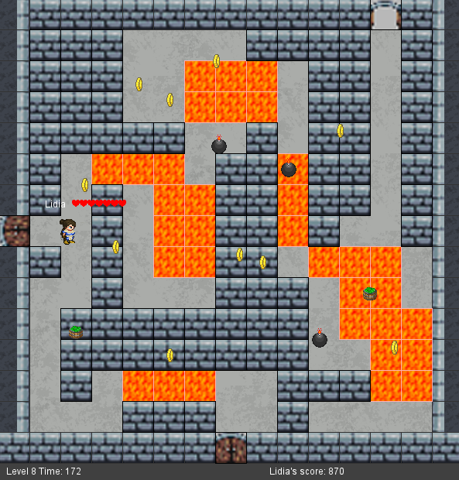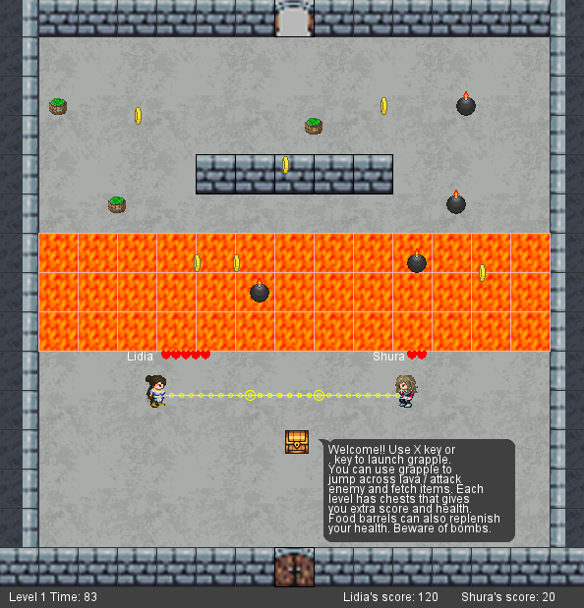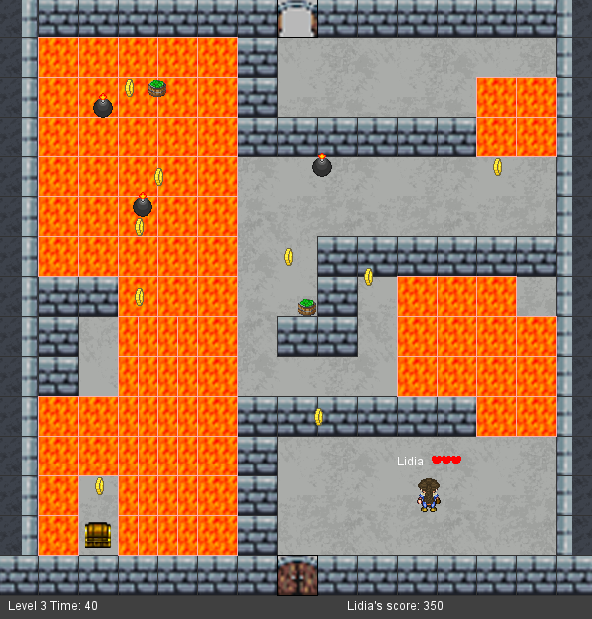

Areas for Improvement

* Smoother graphics
* Remove glitch where objects can spawn inside walls
* Remove glitch where objects can spawn in the same location as the player causing instant damage on spawn

# Contributions Summary

**Bryce:**

* Level layout design.
* Level layout coding.
* Game story.
* Menu design.
* Boss fights design.
* Documentations and presentation.
* Video compilation.
* General bug fixes.
* Play testing.

**Josh:**

* Game design and ideas.
* Story ideas.
* Grapple mechanism coding and design.
* Documentations and presentation.
* Play testing.

**Helen:**

* Game design and ideas.
* Story ideas.
* Menu design.
* Documentation and presentation.
* Play testing.

**Jerry:**

* Game architecture design, core classes and base game functionalities.
* Animations / Audio effects / Game object interaction and collision.
* NPC players generation / NPC dialogue / ChatGPT / Score notification.
* Game AI / End-game levels layout design.
* GitHub repository setup / Code integration.
* Documentation and presentation.
* Bug fixes.
* Play testing.